Dive into Tulamben: Coral Castles and Sunken Secrets
5 days / 4 nights

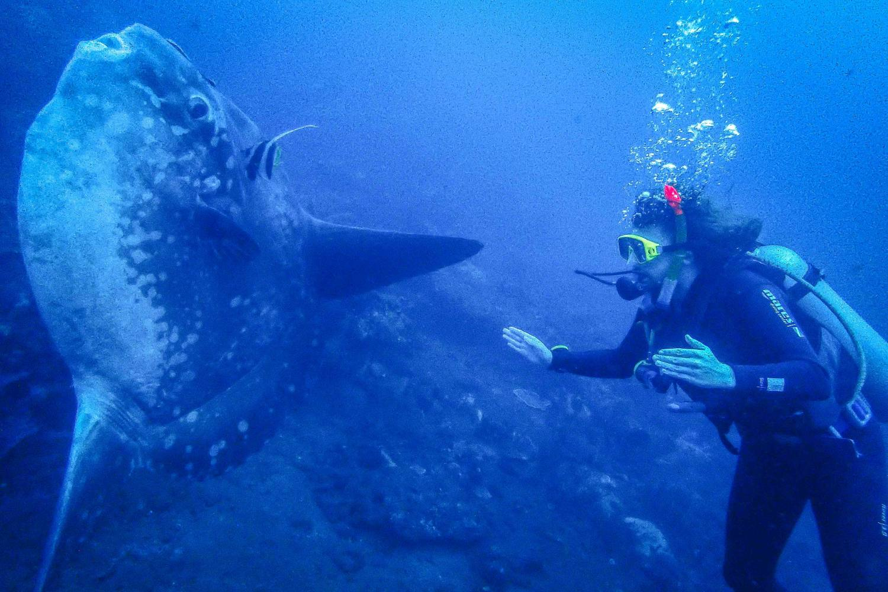

Summarized Itinerary:

Date | Activities
Day 1 | Arrival to Bali. Meet & greet by your driver. Private transfer to Bali Dive Resort and Spa.
Day 2 | Diving – double tank
Day 3 | Diving – double tank
Day 4 | Diving – double tank
Day 5 | Water Castle and Sweet Lookout. Transfer to the airport.

Detailed Itinerary:

Day 1: Welcome to Bali! Transfer to Bali Dive Resort and Spa

A private transfer has been arranged for your convenience upon arrival at Denpasar International Airport (DPS). You will be met at the terminal by your driver who will be waiting with a personalized sign to assist you with your luggage and ensure a smooth, comfortable journey to your destination. We wish you a pleasant arrival and a wonderful stay!

Day 2, 3 and 4 – Double tank dives

Once a quiet, sun-drenched fishing village tucked into the arid folds of Karangasem, Tulamben has transformed into one of Bali’s most sought-after dive destinations—yet it still holds the soul of its humble beginnings. The turning point came in the 1980s, when the sunken WWII cargo ship USAT Liberty was discovered just offshore. Since then, divers from around the world have flocked here to glide along its coral-encrusted hull, now teeming with life and mystery. But Tulamben is far more than a single wreck. Within a 15-minute radius of Bali Dive Resort & Spa, you’ll find dozens of dive sites offering everything from dramatic walls and sloping reefs to world-class muck diving right on our House Reef. It’s a paradise for underwater photographers—nudibranchs, ghost pipefish, and rare critters await in the volcanic sand, while nearby sites like Seraya and Melasti deliver endless macro magic.
Above the depths, Tulamben’s waters are typically calm and crystal clear, making it ideal for all levels of divers. In the shallows, cleaning stations buzz with activity as fish line up for their daily grooming, and deeper down, sea fans and soft corals sway gently in the current—or lack thereof. Whether you're here for a single dive or a week-long immersion, Tulamben offers a rhythm of exploration that’s both exhilarating and meditative, wrapped in the quiet charm of Bali’s northeast coast.

You will get a chance to explore few of the following dive sites:

The USAT Liberty Wreck
This is more than just a dive site—it’s a living monument where history and marine life intertwine beneath the surface. Resting just 30 meters off the coast of Tulamben, this 125-meter-long WWII cargo ship was claimed by the sea in 1963 and has since transformed into one of Bali’s most iconic underwater experiences. Accessible directly from the shore, it’s a gentle entry for divers of all levels, yet what awaits below is anything but ordinary. Nature has draped the wreck in vibrant life: anemones sway beside soft and hard corals, while schools of coral fish dart through rusted beams. Look closer and you’ll find rare treasures—frogfish tucked into crevices, leaf scorpionfish blending into the reef, pygmy seahorses clinging to sea fans, and the elusive mimic octopus performing its underwater masquerade. Out in the blue, eagle rays glide past and, if luck is on your side, even a whale shark might grace the scene. At night or just before sunrise, the wreck pulses with a different energy as a family of hump head parrotfish returns to sleep among the steel bones of the ship. It’s a place where war relics have become coral kingdoms, and every dive feels like a quiet conversation between past and present.

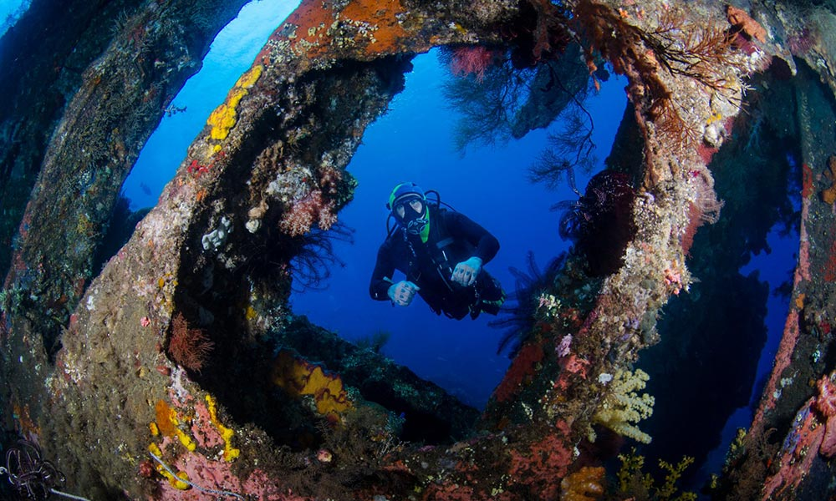

Emerald
Just a few minutes away by traditional jukung boat, Emerald is Tulamben’s closest boat-access dive site—and one of its most enchanting. Unlike the region’s signature black sand, Emerald begins in a calm white sand bay, giving the dive a soft, luminous feel from the very first fin kick. As you descend, the reef reveals itself in layers: massive elephant-ear sponges and finger-like ridges stretch into the depths, creating a textured underwater landscape that feels both expansive and intimate. Along the way to the reef’s split, garden eels sway in the sand, bumphead parrotfish cruise past with prehistoric charm, and tiny ladybugs dot the coral like confetti. As you reach the turning point, the current picks up slightly, ushering in a rush of life. Schools of fusiliers shimmer in formation, sergeant majors dart between coral heads, and if you’re lucky, giant trevallies or eagle rays might glide through the blue. One of Emerald’s quirks is its underwater table—a playful photo op that also hides secrets beneath. Peer under the coral ledges and you might spot baby sharks or stingrays resting in the shadows. With its gentle entry, vibrant reef, and moments of surprise, Emerald is suitable for all levels of divers and remains one of our favorite sites for its quiet beauty and joyful unpredictability.

Sidem
Just a few minutes south of our Tulamben resort lies Sidem, a quiet volcanic stone bay that feels like a hidden chapter in Bali’s dive story. It’s the kind of place where time slows down—perfect for two leisurely dives, with rest areas, showers, rinse tanks, and toilets making it easy to settle in and stay a while. We begin our descent directly in front of the rest area, with multiple paths to explore. Head toward the center of the bay and you’ll enter a macro photographer’s dream: nudibranchs in every color, mantis shrimps peeking from the sand, sea moths gliding like tiny dragons, and boxer crabs waving their anemone gloves. Drift right toward the corner and the terrain shifts—shallow reefs bloom with hard corals and feather stars, ideal for all levels of divers. Here, turtles cruise by with quiet grace, leaf scorpionfish lurk in camouflage, and if you’re lucky, a white tip reef shark might glide past in the distance. Sidem is understated, uncrowded, and full of surprises—a place where the small becomes spectacular and every dive feels personal.

Coral Garden
Nestled between Tulamben’s two iconic dive sites—the USAT Liberty Wreck and the Drop Off—Coral Garden offers a gentle, meandering dive that feels like a quiet exhale. Ideal for beginners and photographers alike, this shallow reef is a playground of color and movement, where clownfish weave through anemones and sunlight dances across coral heads. What makes Coral Garden truly unique is its blend of natural beauty and cultural charm: an artificial reef adorned with Balinese statues and temple carvings adds a touch of mysticism, drawing in curious marine life and creating striking photo opportunities. Moray and ribbon eels peer from crevices, nudibranchs parade across the sand, and macro critters hide in plain sight, waiting to be discovered. Toward the sandy patch, blacktip reef sharks sometimes glide past during your safety stop, adding a thrill to the final moments of your dive. And just beyond the calm shallows, a deep slope disappears into the blue—an open invitation to the unexpected, where anything from pelagics to passing rays might rise from the depths. Coral Garden is proof that even the quietest corners of Tulamben hold stories worth diving into.

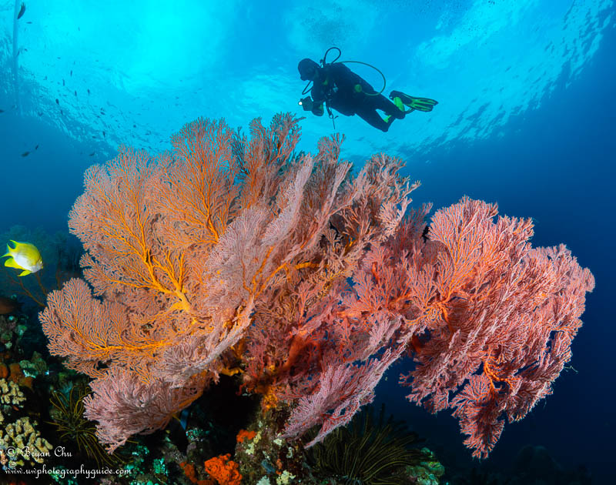

Palung Palung
Tucked between the famed Drop-Off and Batu Kelebit, Palung Palung is a quiet gem reached by a short five-minute boat ride from Bali Dive Tulamben—just enough time to slip into your gear and let the anticipation build. The name means “bowls,” a nod to the site’s unique underwater topography: dramatic drop-offs, sloping ridges, and finger-like formations that stretch out into the deep blue. It’s one of Tulamben’s lesser-dived spots, which means the corals here are pristine, the sponges vibrant, and the marine life refreshingly undisturbed. As you drift along, bumphead parrotfish cruise past like armored knights, garden eels sway in synchronized rhythm, and turtles glide with quiet grace. After surfacing, the boat returns you to the resort, where a cool drink by the pool and the soft hum of post-dive stories await. Palung Palung is the kind of site that surprises you—not with crowds or spectacle, but with serenity, texture, and the feeling that you’ve discovered something just a little bit secret.

The Drop Off
This is a dramatic underwater wall that begins just three meters below the surface and plunges to depths beyond 80 meters—a vertical playground for experienced divers and marine life alike. As you descend, the wall reveals layers of sponge-covered rock teeming with colour and movement. Common reef fish flit between crevices, while frogfish perch like tiny sentinels in camouflage. Nudibranchs trail across the surface in slow, deliberate dances, and leaf scorpionfish hover with eerie stillness. Clown triggerfish flash their bold patterns, and octopuses—some no bigger than your thumb, others stretching wide—emerge from shadowy dens. But the real magic lies in the blue. Look outward, and you might catch the sleek shimmer of a tuna, the powerful glide of a marlin, or the unmistakable silhouette of a shark cruising past. On rare and lucky days, even a mola mola drifts into view, its alien grace captivating in the open water. The Drop Off is a vertical canvas where every meter tells a different story, and every glance holds the promise of something extraordinary.

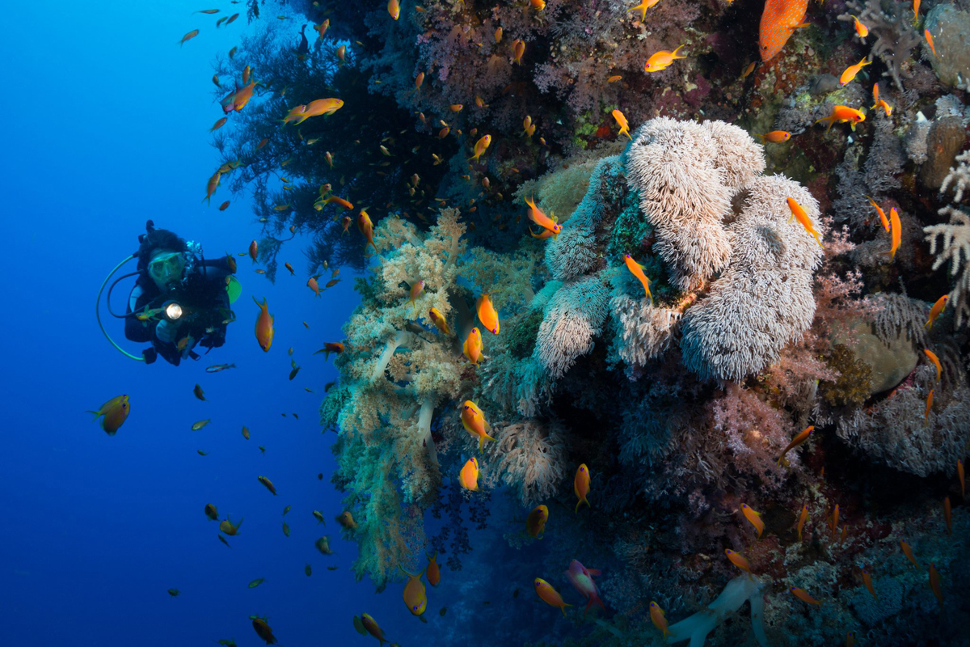

Seraya Secret
Just a few minutes south of Bali Dive Tulamben lies Seraya Secrets—a legendary macro dive site that feels like a treasure hunt in slow motion. The beach is well set up for underwater photographers, with rinse tanks, toilets, and a smooth entry over rounded volcanic stones. Once underwater, the magic begins. Harlequin shrimp parade their bold patterns, ornate ghost pipefish drift like delicate confetti, and pygmy seahorses cling to sea fans with impossible charm. You might even spot a full-sized seahorse or the elusive leopard moray eel peeking from its lair. This is critter diving at its finest—every inch of sand holds a secret, every dive a new discovery. But Seraya demands care: buoyancy control is essential, especially with a camera in hand. Stirring up the bottom not only clouds your shot—it risks damaging the fragile ecosystem that makes this site so special. So move slowly, breathe gently, and let the reef reveal itself.

Day 5 – Departure – Water Palace, Sweet lookout, Denpasar airport
A transfer will be arranged from your hotel to Bali Airport, ensuring a smooth and stress-free departure.
Leaving the quiet shores of Tulamben behind, your journey begins with a gentle ascent into Bali’s eastern highlands, trading coral reefs for cultural reverence.
The first stop is Taman Ujung Water Palace. It isn’t just a stop - it’s a portal into Bali’s layered past. As you arrive, the first thing that strikes you is the harmony between architecture and nature: long, elegant bridges stretch across tranquil ponds, leading to ornate pavilions that seem to float on water. The design blends Balinese grace with European symmetry, a reflection of the raja’s vision to create a space both regal and serene. But beneath its beauty lies a deeper story. The southeastern corner holds the Dirah pool, once used to punish those accused of black magic - its name drawn from the witch queen of the Calonarang legend. This juxtaposition of elegance and mysticism gives the palace a haunting allure. Built in the early 1900s and expanded over decades, the complex evolved from a place of judgment to a royal retreat, eventually opening to the public during Dutch occupation. Today, framed by mountains to the north and the sea to the southwest, it’s a favorite for photographers and dreamers alike. As you wander its pathways, you’re not just admiring a garden, you’re walking through a living tapestry of Bali’s spiritual and political history, where long stone bridges stretch across serene ponds and pavilions float like whispers from another time.
From here, the road winds upward toward Lahangan Sweet, a ridge that feels like the edge of the world. As you step onto the viewpoint, Mt Agung rises in majestic silence, its slopes bathed in light, and on clear days, Mt Rinjani appears across the sea like a distant echo. The air is crisp, the view infinite -moment to breathe in Bali’s grandeur before descending into the foothills.
Nestled among rice terraces and jungle, Bali Asli welcomes you with warmth and wood-fired aromas. Lunch is a celebration of place: sambals ground by hand, vegetables from nearby gardens, and flavors that honor tradition without exploiting it. You dine with a view of sacred peaks, surrounded by the quiet hum of village life. As the afternoon fades, the final leg of your journey begins—winding through valleys and villages, each bend a soft goodbye. By the time you reach Denpasar Airport, Bali has etched itself into your memory—not just through dives and temples, but through the quiet grace of its landscapes, its stories, and the people who shared them with you.

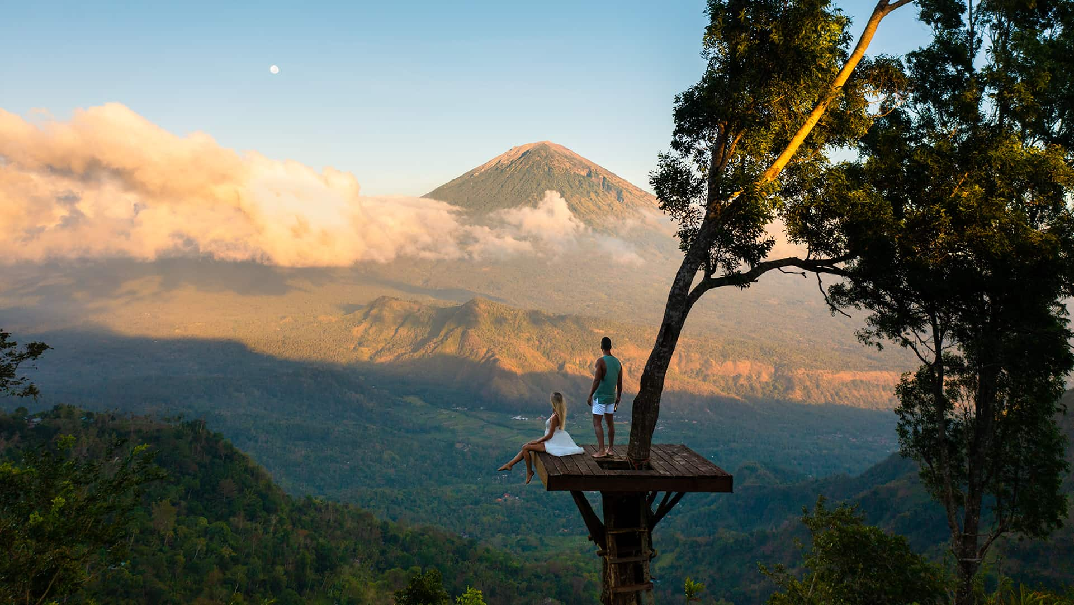

✅ INCLUDED:
- Private transport from Denpasar Airport to Bali Dive Resort & Spa with a friendly, local-language driver
- 4 nights’ accommodation at Bali Dive Resort in the room category of your choice
- Daily breakfasts and all applicable taxes
- 3 days of diving, with two tanks per day—including the iconic USAT Liberty Wreck
  - All dive equipment is provided except dive computer, flashlights, and any surcharges for early morning or night dives
  - Free Nitrox for Nitrox certified divers
- Return transport to Denpasar Airport with scenic stops at:
  - Taman Ujung Water Palace
  - Lahangan Sweet Lookout
  - Bali Asli Restaurant for a locally sourced lunch
- Full board meals, starting with dinner on Day 1 and ending with breakfast on Day 6
❌ EXCLUDED:

- Travel insurance of any kind
- Gratuities to guides and crew
- Additional meals and minibar charges at the hotel
- Laundry, phone calls, and room service at the hotel
- Shopping and other personal expenses
- Costs incurred due to flight delays or cancellations
- Services not in “Included” section
- Dive computer, flashlights, and any surcharges for early morning or night dives

Rate per person for two guests travelling together sharing activities and room according to chosen room type:

Bali Dive Resort and Spa – Deluxe Room Partial Ocean View | USD 895

All rates subject to reconfirmation at the time of booking, and are subject to change due to currency fluctuations, increase of fees, etc.US

Bali Dive Resort and Spa

Bali Dive Resort & Spa in Tulamben is a serene gateway to Bali’s northeast coast, where world-class diving meets laid-back luxury. Nestled between volcanic slopes and the shimmering sea, the resort offers direct access to iconic dive sites like the USAT Liberty Wreck and Coral Garden, with vibrant reefs just steps from your room. Whether you're here to explore the underwater wonders, unwind by the pool, or soak in the quiet charm of Tulamben, Bali Dive Resort & Spa blends comfort, adventure, and authentic Balinese hospitality in one unforgettable experience.

